About Us
The Rights and Resources Initiative (RRI) is a global coalition of organizations working to encourage forest land tenure and policy reforms and the transformation of the forest economy so that business reflects local development agendas and supports local livelihoods. RRI works at country, regional and global levels, collaborating on research, advocacy and convening strategic actors.

The RRI Coalition is formed by a group of core Partners who work in areas of their regional and thematic expertise. Partners also engage with a wide group of Collaborators who participate in and support RRI activities. Our 14 Partners and 140 plus Collaborator organizations are directly engaged in land and forest policy reforms in countries throughout Africa, Asia and Latin America. Together, we are working to encourage greater global commitment and action on pro-poor tenure, policy and market reforms.

RRI goes beyond the traditional set of international development actors to involve a wide spectrum of organizations, each which provides a critical perspective necessary to advance change.

The Rights and Resources Group (RRG) is a non-profit organization based in Washington, DC, that leads the global-level analysis and advocacy, catalyzes new strategic collaboration and advisory groups, and coordinates the governance and activities of the Initiative.

Global Challenge, Global Opportunity
The world is at a turning point in a global land grab and a battle to slow climate change, with dozens of new players, including the BRICs and Middle Eastern nations.

Forests cover close to 30 percent of the world's land area, and more than a billion people rely on forests to a significant extent for their food, fuel and income. Indigenous Peoples and local communities are increasingly locked out of access to their only real source of wealth—land and its resources. At risk are political stability as well as food security and the goals of development as a tool for reducing poverty and hunger in the poorest nations

Dominant models of forest industry and conservation have often exacerbated poverty and social conflicts and have precluded pro-poor economic growth. The lack of clear rights to own and use forest land, develop enterprises, and trade in forest products has driven millions of forest dwellers to poverty, encouraged widespread illegal logging and resulted in massive forest loss.

The world will not meet global goals to reduce poverty and protect the environment unless rights to land and resources are strengthened. Nor will the world effectively mitigate or adapt to climate change without clarifying local tenure and governance. The next two decades are critical for people and forests.

There are reasons for optimism. Indigenous Peoples and local communities are gaining voice and opportunity, and after decades of limited action many countries are beginning to consider far-reaching legal and policy reforms. This turning point is a major opportunity to advance the rights and livelihoods of forest-dependent peoples by establishing the institutional foundations for sustained conservation and forest-based economic development.

Core Beliefs
Based on our experience, we find that empowerment of rural people and asset-based development are part of a process that is dependent on a set of enabling conditions, including security of tenure to access and use natural resources. As a coalition of diverse and varied organizations, RRI is guided by a set of core beliefs.

- Rights of Poor Communities Must Be Recognized and Strengthened

We believe it is possible to achieve the seemingly irreconcilable goals of alleviating poverty, conserving forests and encouraging sustained economic growth in forested regions. However, for this to happen, the rights of poor communities to forests and trees, as well as their rights to participate fully in markets and the political processes that regulate forest use, must be recognized and strengthened.

- Progress Requires Supporting and Responding to Local Communities

We believe that progress requires supporting, and responding to, local community organizations and their efforts to advance their own well-being.

- Now is the Time to Act

We believe that the next few decades are particularly critical. They represent an historic moment where there can be either dramatic gains, or losses, in the lives and well-being of the forest poor, as well as in the conservation and restoration of the world’s threatened forests.

- Progress Requires Engagement and Constructive Participation by All

It is clear that progress on the necessary tenure and policy reforms requires constructive participation by communities, governments and the private sector, as well as new research and analysis of policy options and new mechanisms to share learning between communities, governments and the private sector.

- Reforming Forest Tenure and Governance Requires a Focused and Sustained Global Effort

Reforming forest tenure and governance to the scale necessary to achieve either the Millennium Development Goals, or the broader goals of improved well-being, forest conservation and sustained-forest-based economic growth will require a new, clearly focused and sustained global effort.

- Millennium Development Goal 1: Eradicate extreme poverty
- Millennium Development Goal 7: Ensure environmental sustainability, with a target of halving the proportion of people whose income is less than US$1 a day by 2015

The experience and beliefs of the founding Partners are the basis for the Initiative’s focus on rights and governance. They are also the basis for RRI’s Mission, Goals, and Targets .

Mission
RRI’s Mission is to support local communities’ and indigenous peoples’ struggles against poverty and marginalization by promoting greater global commitment and action towards policy, market and legal reforms that secure their rights to own, control and benefit from natural resources, especially land and forests.

Goals
The Rights and Resources Initiative will support communities, governments, donors and international institutions to combine efforts to advance two global goals:

  - To substantially increase the forest area under local ownership and administration, with secure rights to conserve, use and trade products and services.

  - To dramatically reduce poverty in the forested areas of the world.

Targets
The Initiative will advocate two targets as global indicators of progress – both situated within the framework of the Millennium Development Goals:

- To reduce by half the proportion of people in forest areas who live in extreme poverty by 2015. The Initiative will encourage governments to adopt the necessary reforms, and provide the development flows required, to tackle poverty in forest areas.

- To double the global forest area under local ownership and administration, with secure rights to use and trade products and services, by 2015. Many countries have made progress in strengthening and reforming forest tenure, but unclear rights remain the norm rather than the exception for the majority of the world’s forests and forest peoples.

Leadership
Coordination of the Rights and Resources Initiative is conducted by the Rights and Resources Group, a non-profit 501 c (3) organization based on Washington DC, United States.

Andy White begin_of_the_skype_highlighting end_of_the_skype_highlighting
Coordinator, Rights and Resources Initiative
Prior to helping create and establish RRI, Andy served as Senior Director of Programs at Forest Trends and Natural Resource Management Specialist at the World Bank, as well as worked as a consultant to the International Food Policy Research Center, Save the Children Federation and the Inter-American Foundation. He has worked extensively in Haiti, Mexico and China and supervises policy research, advocacy and policy engagement in Asia, Latin America and Africa. His research and publications have focused on forest tenure and policy, as well as the role of forests and communities in climate change.
awhite@rightsandresources.org

Arvind Khare
Executive Director, Rights and Resources Group
Arvind is a natural resources management specialist with more than twenty years of experience in the non-profit, corporate and public sectors. During this period he made significant contributions to the critical examination of poverty-environment linkages. His work has involved the development and analysis of policies in infrastructure, forestry, private and public sector enterprises, tribal development, social development and watershed sectors for the state and central governments of India.
akhare@rightsandresources.org

Contacts

Andy White begin_of_the_skype_highlighting end_of_the_skype_highlighting
Coordinator, Rights and Resources Initiative
Media Contact

Jenna DiPaolo
Senior Manager, Strategic Communications
JDiPaolo@rightsandresources.org
+1 202 470 3894
+1 202 412 0331

Madiha W. Qureshi
Senior Associate, Production & Media Engagement mqureshi@rightsandresources.org
+1 202 470 3886

Rights and Resources Initiative
1238 Wisconsin Ave NW
Ste. 300
Washington, D.C. 20016
USA

awhite@rightsandresources.org

Arvind Khare
Executive Director, Rights and Resources Group
akhare@rightsandresources.org

Janis Alcorn
Senior Director, Country and Regional Programs
jalcorn@rightsandresources.org

Jenny Springer
Director, Global Programs
jspringer@rightsandresources.org

Luis Colomer
Chief Operations Officer
lcolomer@rightsandresources.org

James Christopher Miller
Director, Finance and Administration
jcmiller@rightsandresources.org

Get up to the minute information:
Follow Rights and Resources Initiative on Facebook and Twitter!

List of Partners
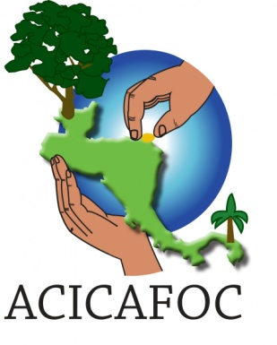

ACICAFOC is the Coordinating Association of Indigenous and Community Agroforestry in Central America. It is a non-profit, social community-based organization from Central America, which groups associations, cooperative societies, federations and grass roots organizations led by small and medium agro forestry producers, indigenous peoples and farmer peasants. These groups work for the access, use and management of natural resources, seeking food security, integrated ecomanagement and economic sustainability for their communities through diversified livelihoods and conservation. For more information, visit the ACICAFOC website.


The Centre for Environment and Development (CED) was created in 1995 with the specific aim of realizing sustainable management of Central Africa’s forests. CED was created to counter the rising threats to forests observed during the 1990s, and situates itself firmly within the local context (where forest destruction takes place, and where its impacts are felt most strongly among communities), as well as the national level (the seat of decision making that leads to or legitimizes deforestation and the dispossession of local peoples). CED also works on the international level where decisions are made affecting the forests and lives of millions of people. For more information, visit the CED website.


Civic Response was founded in 2003 by a group of social activists with a wide experience of campaigns in Ghana and internationally. Civic Response works to deepen the political economic analysis of grassroots groupings and to facilitate their networking towards the emergence of articulate social movements that could lead in the democratization and development of African societies and in international development struggles. For more information, visit the Civic Response website.

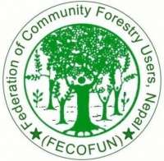
The Federation of Community Forestry Users, Nepal (FECOFUN) is a formal network of Community Based Forest User Groups from all over Nepal. FECOFUN emerged from the idea that forest users from all parts of the country should be linked in order to strengthen the role of users in policy making processes. Since its inception in July 1995, FECOFUN has grown into a social movement organization with about 8.5 million people represented - all of whom are forest users. More than 11,200 Community Forest User Groups are affiliated with FECOFUN. For more information see the FECOFUN website.

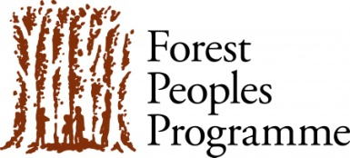
Forest Peoples Programme supports forest peoples to secure and sustainably manage their forests, lands and livelihoods. Our strategies to achieve this include: (a) promoting the rights and interests of forest peoples at local, national and international levels; (b) creating space for forest peoples to have an effective voice in decision-making processes; (c) challenging top-down policies and projects that deprive local peoples of resources; (d) coordinating support among environmental organizations for forest peoples' vision; (e) supporting community-led sustainable forest management; and (f) publicizing forest peoples' plight through research, analysis and documentation. For more information, visit the Forest Peoples Programme website.

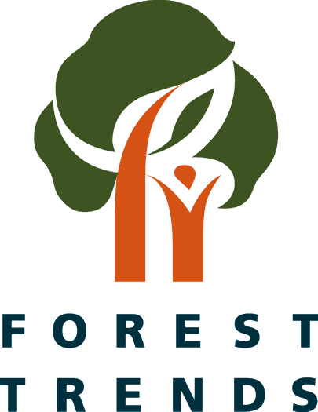
Forest Trends is an international non-profit organization that works to expand the value of forests to society; to promote sustainable forest management and conservation by creating and capturing market values for ecosystem services; to support innovative projects and companies that are developing these new markets; and to enhance the livelihoods of local communities living in and around those forests.
We analyze strategic market and policy issues, catalyze connections between forward-looking producers, communities and investors, and develop new financial tools to help markets work for conservation and people. For more information visit the Forest Trends website.

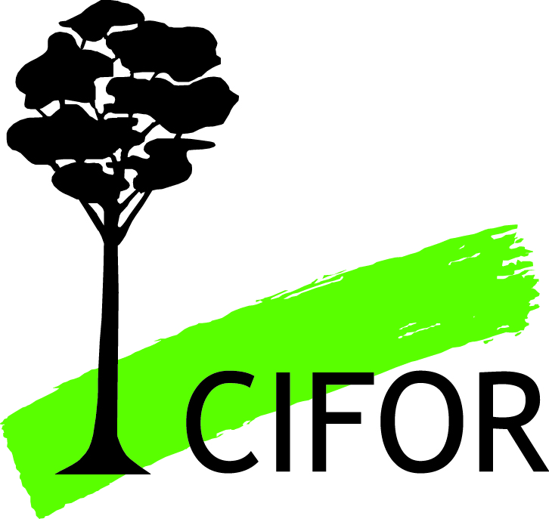
The Foundation for People and Community Development facilitates the improvement of people’s quality of life by alleviating poverty, promoting good health, education and sustainable resource use through shared commitment and long-term partnerships with local communities. FPCD has an active program of support to indigenous landowners for capacity building and support to forest management and timber harvesting and processing enterprises, and to improved market linkages to domestic and export markets.

For more information, visit the FPCD website.

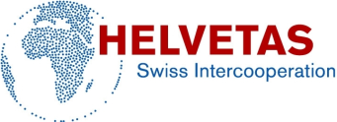
HELVETAS Swiss Intercooperation is a member-based, non-profit organization that is engaged in 30 partner countries throughout Africa, Asia, Latin America and Eastern Europe. Based in Switzerland, the primary focus of Helvetas Swiss Intercooperation is to:
- Reduce poverty through specific, sustainable development projects and advisory services
- Inform the Swiss public about its work and raise awareness concerning global injustice and the necessity to stand up for the needs of the world's poorest populations.
- Promote fair trade of products such as cocoa, rice and cotton from developing countries.
- Participate in global networks, petitions and as a member of Alliance Sud to take a public stance on development issues within Switzerland and internationally.
For more information visit the HELVETAS Swiss Intercooperation website.

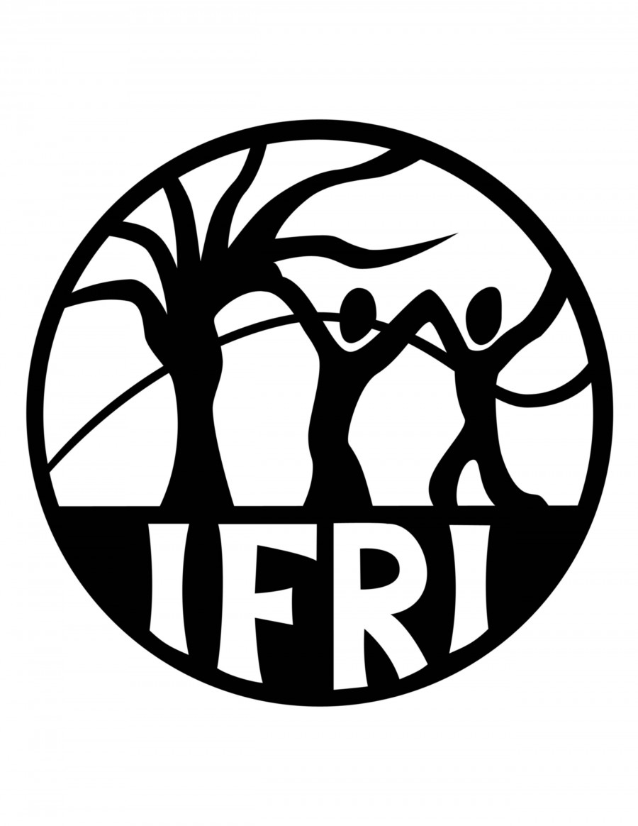
The primary mission of IFRI is to examine how governance arrangements shape forest outcomes in terms of both social and environmental dimensions. Scholars and policy makers affiliated with IFRI are interested in understanding the role of formal and informal institutions in enhancing livelihoods and adaptive capacity of peoples, conserving biodiversity, and promoting greater sustainability in carbon sequestration. IFRI’s goal is to carry out rigorous research that can help policy makers and forest users design and implement improved evidence-based forest policies. Most importantly, IFRI comprises partner collaborating research institutes in North America, Latin America, Asia, and Africa. As such, it draws on localized knowledge and perspectives in developing its program, and promotes interdisciplinary research and analysis that enables comparability across regions. For more information go to IFRI's website.


PRISMA (Salvadoran Research Program on Development and Environment) is a policy-oriented research center founded in El Salvador in 1993. Their mission is to work for the social and environmental revalorization of rural communities and territories as an integral aspect of development processes. Our vision is societies that advance toward greater social justice and environmental sustainability.
PRISMA serves as a regional platform for dialogue, critical analysis and action. This platform is an ongoing process, a social construction, based on the following key elements:
• A shared concern by all participants for improving the livelihoods of poor marginalized communities and promoting sustainable development.
• A commitment to a genuine dialogue among different perspectives, focuses and points of view.
• Fomenting interaction among diverse actors, representing diverse sectors and disciplines, and engaged at a variety of levels. For more information go to PRISMA's website.

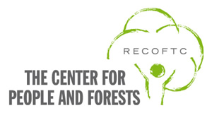
RECOFTC – The Center for People and Forests is an international organization specializing in community forestry and devolved forest management in Asia and the Pacific. It works to see more communities actively managing more forests in the region to ensure optimal social, economic, and environmental benefits. Since its founding in 1987, RECOFTC has trained more than 10,000 people from over 20 countries in devolved forest management: from national policy makers, researchers, and practitioners right through to local forest users. Training services and learning events are complemented by on-the-ground projects, critical issue analysis, and strategic communications. For more information visit the RECOFTC website.

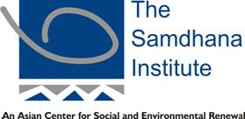
The Samdhana Institute was formed in 2003 by a group of individuals, conservationists, development practitioners, constituting the first Samdhana Fellows; moved by the same commitment of 'giving back' what they know to the next generation; and bringing together skills, knowledge, experiences, networks, colleagues and friends; delivering maturity, strength and sustainability.

Samdhana's vision is a region where natural, cultural and spiritual diversity are valued, where environmental conflicts are resolved peacefully, with justice and equity. With a growing network of fellows, Samdhana assists in environmental conflict and mediation support and helps local organizations to reflect upon their approaches to: i) problem identification and strategic planning; ii) leading change processes; iii) monitoring and assessment; iv) reflection upon effectiveness. For more information, visit the Samdhana Institute website.

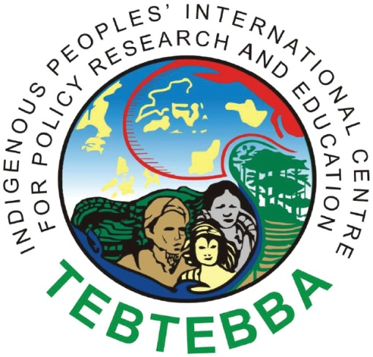
Tebtebba (Indigenous Peoples' International Centre for Policy Research and Education) is an indigenous peoples' organization born out of the need for heightened advocacy to have the rights of indigenous peoples recognized, respected and protected worldwide. Established in 1996, Tebtebba seeks to promote a better understanding of the world's indigenous peoples, their worldviews, their issues and concerns. In this effort, it strives to bring indigenous peoples together to take the lead in policy advocacy and campaigns on all issues affecting them. For more information, visit the Tebtebba website.

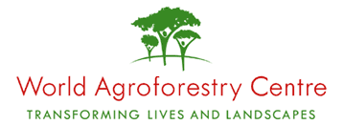
The World Agroforestry Centre (ICRAF), headquartered in Nairobi, Kenya, is part of the Consultative Group on International Agricultural Research. ICRAF’s primary mission is to advance the science and practice of agroforesty and in doing so, transform the lives and landscapes of the rural poor in developing countries. ICRAF operates in over 20 countries throughout the tropics. ICRAF program research areas are Land and People, Trees and Markets, Environmental Services and Strengthening Institutions Policy research cross-cuts each of these programs. For more information visit the World Agroforestry Centre website.

